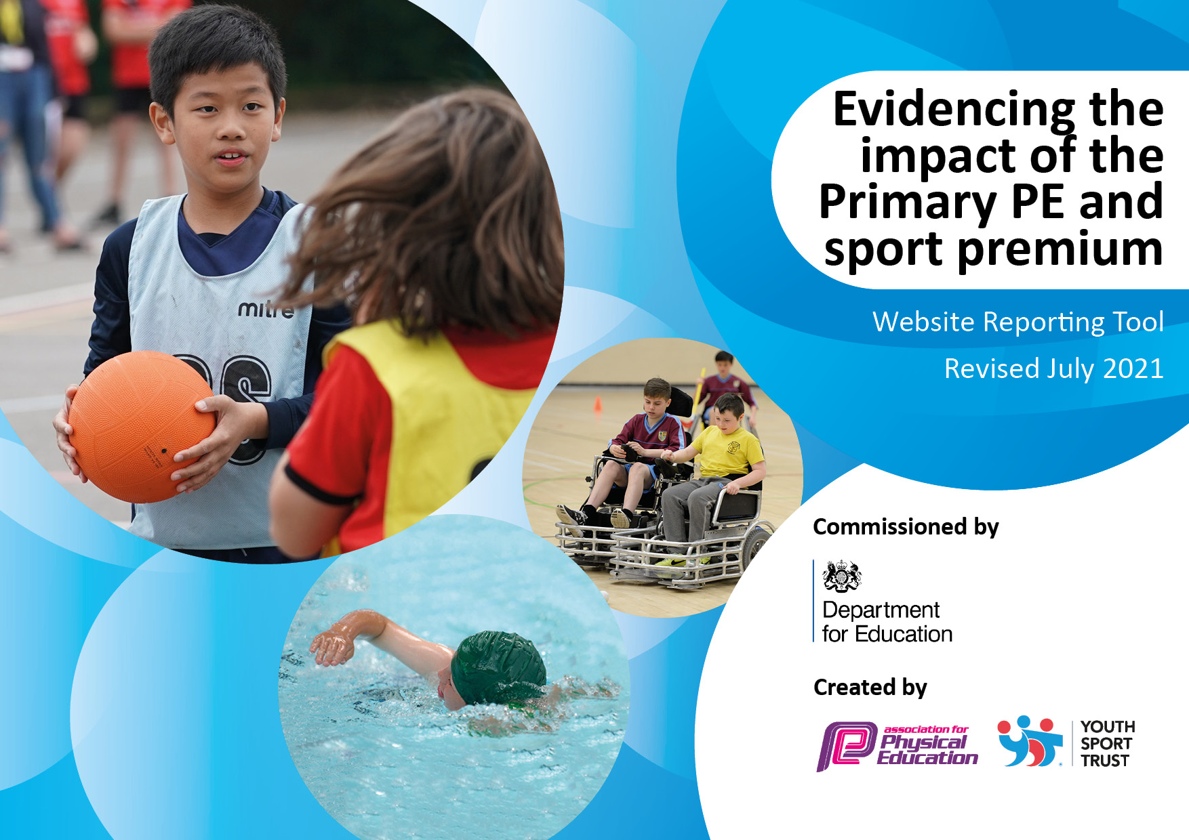
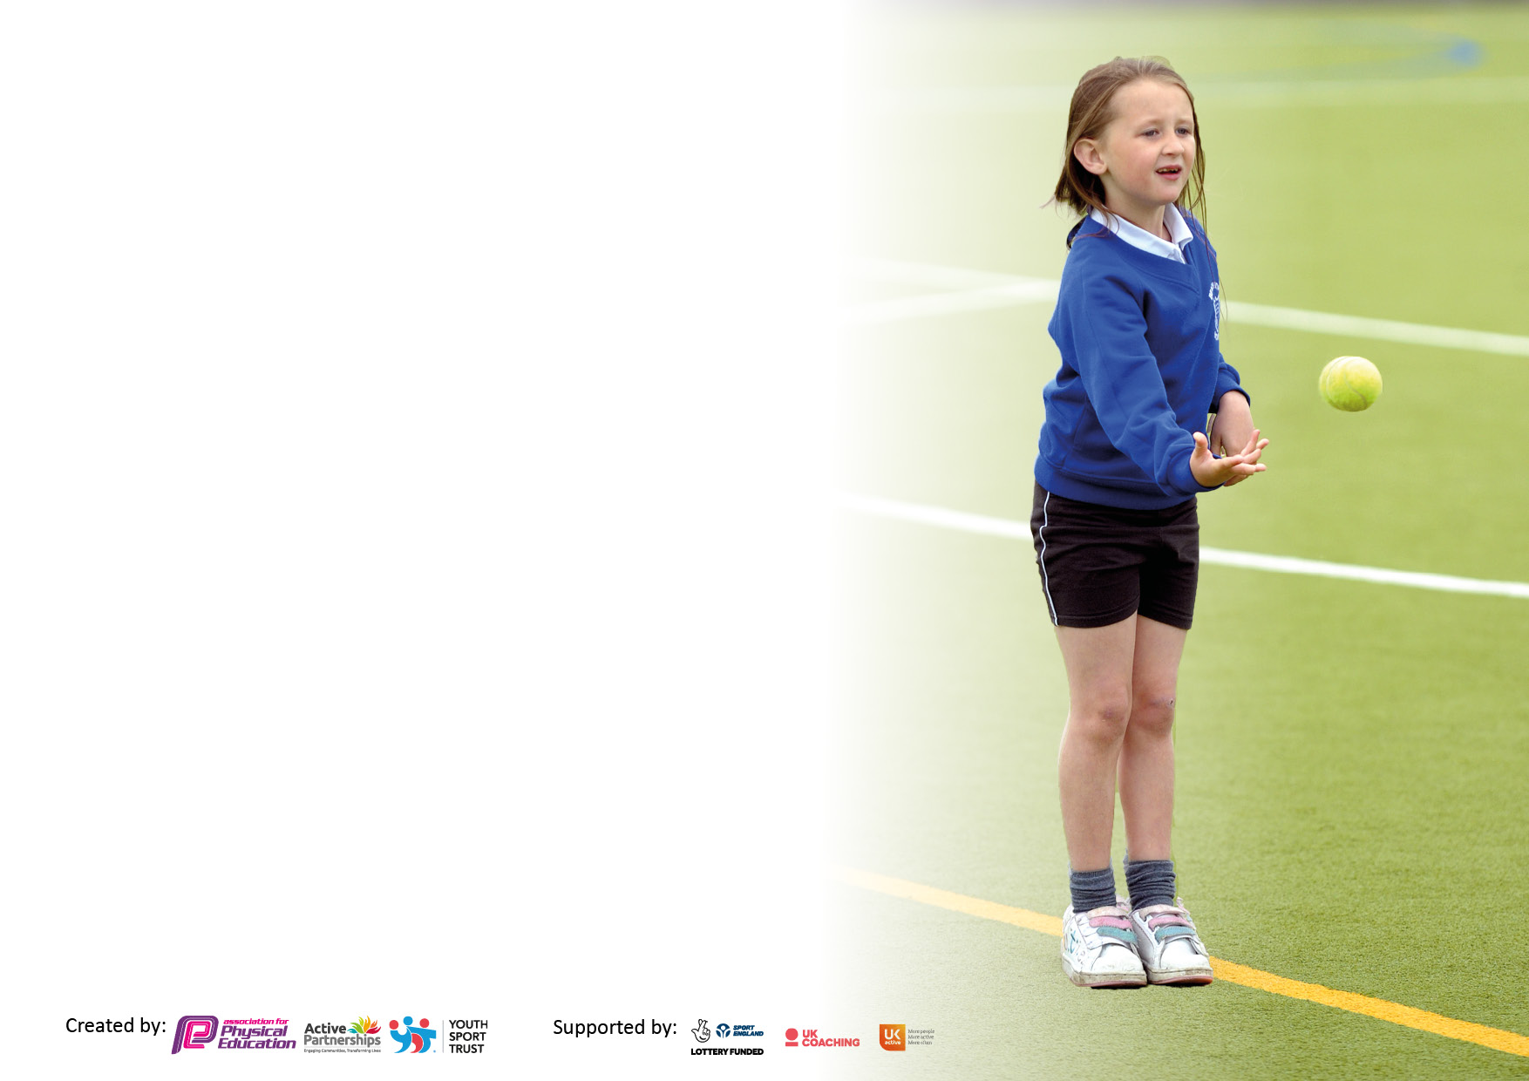

It is important that your grant is used effectively and based on school need. The Education Inspection Framework makes clear there will be a focus on ‘whether leaders and those responsible for governors all understand their respective roles and perform these in a way that enhances the effectiveness of the school’.

Under the Quality of Education Ofsted inspectors consider:
Intent - Curriculum design, coverage and appropriateness
Implementation - Curriculum delivery, Teaching (pedagogy) and Assessment
Impact - Attainment and progress

To assist schools with common transferable language this template has been developed to utilise the same three headings which should make your plans easily transferable between working documents.

Schools must use the funding to make additional and sustainable improvements to the quality of Physical Education, School Sport and Physical Activity (PESSPA) they offer. This means that you should use the Primary PE and sport premium to:

- Develop or add to the PESSPA activities that your school already offer
- Build capacity and capability within the school to ensure that improvements made now will benefit pupils joining the school in future years
- The Primary PE and sport premium should not be used to fund capital spend projects; the school’s budget should fund these.

Pleasevisitgov.ukfortherevisedDfEguidanceincludingthe5keyindicatorsacrosswhichschoolsshoulddemonstrate animprovement.Thisdocumentwillhelpyoutoreviewyourprovisionandtoreportyourspend.DfEencouragesschools to use this template as an effective way of meeting the reporting requirements of the Primary PE and sport premium.

We recommend you start by reflecting on the impact of current provision and reviewing the previous spend.

Schools are required to publish details of how they spend this funding, including any under-spend from 2019/2020, as well as on the impact it has on pupils’ PE and sport participation and attainment. All funding must be spent by 31st July 2022.

We recommend regularly updating the table and publishing it on your website throughout the year. This evidences your ongoing self-evaluation of how you are using the funding to secure maximum, sustainable impact. Final copy must be posted on your website by the end of the academic year and no later than the 31st July 2021. To see an example of how to complete the table please click HERE.
Created by: Supported by:

Details with regard to funding
Please complete the table below.

Total amount carried over from 2021/22 | £ 0
Total amount allocated for 2022/23 | £ 19, 040
How much (if any) do you intend to carry over from this total fund into 2022/23? | £ 0
Total amount allocated for 2023/24 | £18, 830
Total amount of funding for 2023/24. To be spent and reported on by 31st July 2024. | £18, 830
Swimming Data
Please report on your Swimming Data below.

Meeting national curriculum requirements for swimming and water safety.

N.B. Complete this section to your best ability. For example you might have practised safe self-rescue techniques on dry land which you can then transfer to the pool when school swimming restarts.
Due to exceptional circumstances priority should be given to ensuring that pupils can perform safe self-rescue even if they do not fully meet the first two requirements of the NC programme of study
What percentage of your current Year 6 cohort swim competently, confidently and proficiently over a distance of at least 25 metres?  N.B. Even though your pupils may swim in another year please report on their attainment on leaving primary school at the end of the summer term 2021.  Please see note above | 26%
What percentage of your current Year 6 cohort use a range of strokes effectively [for example, front crawl, backstroke and breaststroke]?  Please see note above | 26%
What percentage of your current Year 6 cohort perform safe self-rescue in different water-based situations? | 10%
Schools can choose to use the Primary PE and sport premium to provide additional provision for swimming but this must be for activity over and above the national curriculum requirements. Have you used it in this way? | No

Action Plan and Budget Tracking
Capture your intended annual spend against the 5 key indicators. Clarify the success criteria and evidence of impact that you intend to measure to evaluate for pupils today and for the future.

Academic Year: 2022/23 | Total fund allocated: | Date Updated: July 2023
Key indicator 1: The engagement of all pupils in regular physical activity – Chief Medical Officers guidelines recommend that primary school pupils undertake at least 30 minutes of physical activity a day in school
Intent | Implementation |  | Impact | Sustainability and suggested next steps:
In addition to their PE lessons, children will be encouraged to take part other regular opportunities to encourage physical activity through the week.  Sports and active clubs before and after school will provide children with opportunities to take part in sport. Groups who are less likely to take part will be targeted, and involved in choosing the activities they take part in.  We have a dance scheme linked to the curriculum to encourage regular physical activity and develop children dance and gross motor skills. | Children will take part in our daily mile activities. A clear timetable will be in place to ensure this is completed.  All children will have access to a range of fun activities at play and lunch to encourage them to be active, work together and try different things  This is planned into the curriculum as six hours over the year minimum. | Funding allocated  £9,200 | Children enjoy physical activity. There is lots of choice and this allows children to choose and try different things. Children actively choose to engage in activities at play and lunch. Engagement in activities at play and lunch is high.  More children are choosing to take part in extra-curricular sport activities and attendance is high. | All activities will continue next year. We will further develop the playground activity choices and look to develop sports champions to help children to engage further.  We will review and identify participation in our sports clubs any identify any other key groups that need targeting.
Key indicator 2: The profile of PESSPA being raised across the school as a tool for whole school improvement
Intent | Implementation |  | Impact
Your school focus should be clear what you want the pupils to know and be able to do and about  what they need to learn and to  consolidate through practice: | Make sure your actions to achieve are linked to your intentions: | Funding allocated: | Evidence of impact: what do pupils now know and what can they now do? What has changed? | Sustainability and suggested next steps:
Support children to make links between sport and being active and the positive impacts this has on their health and wellbeing  We will raise awareness and promote activities with families and the community of local sports activities and events through letters, leaflets and Class Dojo  Celebrate sporting achievements, through sports awards and achievements. This includes s sports ‘star of the week’  The curriculum has been updated so it is specifically references the impact on sport on the body and general health.  Invite in famous sports champions to inspire children to get more involved in sport. | This will be supported through our PSHE and PE curriculums and other activities such as the daily mile and walk around equator underpinned be our wellbeing champions. Teachers will explicitly teach the positive benefits encourage children to make healthy choices.  Regular activities posted sent out to families  These activities are linked to house cup through sports day, inter-house competitions, and archery. Sporting achievement will be recognised at the end of the year for leaving pupils, and weekly achievement assemblies.  Long and medium term plans have been updated to include the appropriate content.  Johnny Brownlee and Bex Rayner visited and talked and did activities with the children. | £750 | Children can articulate the positive impacts that sport and activity have on their health and wellbeing. They also enjoy part in these activities and can talk about how it makes them feel better.  Sport is high profile in school. Pupils talk about and enjoy taking part. We have good engagement from parents during sports day.  Sports clubs are better attended.  Children really loved meeting their sporting heroes. | Encouraging children to be healthy and take part in sport continues to be priority for the school, and we continue to develop these links across the curriculum, building on the success of this year.  We will continue to ensure the profile of sport and physical activity is high profile.  We will links these to sporting events that happening nationally and internationally.  Clubs will be actively promoted, with a specific focus on encouraging more KS1 children to attend. Clubs will also be run at more accessible times such as lunchtime.  Continue to bring in other sporting heroes.

Key indicator 3: Increased confidence, knowledge and skills of all staff in teaching PE and sport
Intent | Implementation |  | Impact
Your school focus should be clear | Make sure your actions to | Funding | Evidence of impact: what do | Sustainability and suggested
what you want the pupils to know | achieve are linked to your | allocated: | pupils now know and what | next steps:
and be able to do and about | intentions: |  | can they now do? What has
what they need to learn and to |  |  | changed?:
consolidate through practice:
To support our sports coach in further expanding the sport and physical activity opportunities the children experience, linked to the curriculum  Further develop our expertise of supporting our SEND pupils in getting the most out PE curriculum  Specialist support staff to support SEND children specifically in sport  To establish a PE lead to develop our curriculum, working with a specialist from a local secondary school.  To take part in Commando Joe Training and roll the programme out across school.  Identify and introduce a dance scheme. | Continue to develop the experiential learning offer, applying bushcraft skills through the curriculum and outdoor learning.  The sports coach will liaise with our SENCo who offer guidance. The SENCo and coach will support work with our PE teaching assistant on how best to support children with specific needs.  Drawing assessment information, and considering the impact of pandemic, update and resource our curriculum to ensure it is meeting the needs of all pupils.  Sports coach and all teaching staff have taken part in Commando Joe training, and then link it in with our topic and to support pupils with specific needs.  All teachers to have taken part in i-moves training and it will then be rolled out. | £5500 | This has enhanced and enriched our curriculum and given meaningful experiences that are active and supported learning in foundation subjects.  Pupils with specific needs can better access the full curriculum. By a specialist TA they have better specific knowledge of supporting SEND children.  By focusing on multi-skills for the younger, and then more sport specific skills for the older, we can better address any gaps and children are securing those core generic skills. | The TA will continue to support these children next year. They will be able to use the knowledge they already have to build on children’s progress from last year.  The dance and Commando Joe schemes will be embedded and will be evaluated and reviewed.  Review and evaluate again to identify next steps.
Key indicator 4: Broader experience of a range of sports and activities offered to all pupils
Intent | Implementation |  | Impact
Your school focus should be clear | Make sure your actions to | Funding | Evidence of impact: what do | Sustainability and suggested
what you want the pupils to know | achieve are linked to your | allocated: | pupils now know and what | next steps:
and be able to do and about | intentions: |  | can they now do? What has
what they need to learn and to |  |  | changed?:
consolidate through practice:
Develop and implement a leadership strand within the curriculum from Year 1 upwards.  To give children opportunity to broaden their experiences and skills and develop an appreciation of their local area through a range of outdoor pursuits.  Give children practical and active experiences linked to other areas of the curriculum to develop an understanding and appreciation of those subjects.  Year 4 to access the local climbing wall. | Children will be able to make their own choices and start to lead games, being aware of their own strengths and weaknesses, and evaluate their own and others performances.  Most years groups will be involved in enrichment activities including the Year 4 enrichment week, Year 5 river study and Year 1 seasonal walks.  Liaise with the sports lead at the local secondary to support this. | £100 | Pupil are able to put together their own programme. They are able to talk about they have made and how this benefits them.  Pupils really enjoyed the week. The activities and developed a better understanding their local area. They developed team skills, resilience and confidence in themselves.  Pupils really enjoyed these activities. They are very memorable and have helped children have an understanding of the subject they studying. | Review and evaluate so this can be built on next year.  Run this next year. Use feedback from the children to look at how we can further enhance it.  Look for further opportunities to incorporate these kinds of experiences in to the curriculum.

Key indicator 5: Increased participation in competitive sport
Intent | Implementation |  | Impact
Your school focus should be clear | Make sure your actions to | Funding | Evidence of impact: what do | Sustainability and suggested
what you want the pupils to know | achieve are linked to your | allocated: | pupils now know and what | next steps:
and be able to do and about | intentions: |  | can they now do? What has
what they need to learn and to |  |  | changed?:
consolidate through practice:
All pupil will give the opportunity to take part in a range of in school competitions across the year as well as sports day in the summer.  Children in Year 5 and 6 will have the chance to compete with children from other schools through our linking communities schools group.  To try and reduce the Year 7 and 8 drop off in sport engagement by girl through the Girl Can club  Take part in inter school sports activities including cross country, cycling and triathlon events. | Inter-house competitions will run each term, give children a chance to compete in a wide variety of traditional and alternative sporting activities.  This will include activities such as cycling and triathlon run at one of the local secondary schools  These clubs will target girls. They will be given the opportunities to be involved in what happens at the clubs to encourage participation and build confidence.  This will be coordinated through Keighley Schools and the locals secondary responsible for developing inter school sports. | £3500 | All pupils really enjoy taking part. Because some of the activities are new experiences for all children, it is more inclusive supporting them all in being successful.  Pupils really enjoyed taking part. The opportunity to compete with children from other schools will also help them with transition to secondary.  We had good participation in the clubs. The girl really enjoy them and being able to make choices about the activities they did. | This will continue next year. One of the local secondary school is now our sports hub, and we will closely with them to develop more opportunities for children to take part in competitive sport with other schools.  We will continue to take part in the events next year.  These clubs will continue to run next year. We will also look at if their are any other groups we need to target.

