SEND at Holycroft Primary School
Report to Governors on the Implementation of the
Special Educational Needs and Disability (SEND) Policy in Practice

Schools have a duty to report to parents on the provision for SEND and implementation of their disability equality scheme. Children with special educational needs have learning difficulties or disabilities that make it harder for them to learn than most children of the same age. These children may need extra or different support from that given to other children of the same age.
The Special Educational Needs Code of Practice lies at the heart of Holycroft’s SEND policy and sets out the processes and procedures that we follow to meet the needs of our children. The Code describes a graduated approach which recognises that children learn in different ways and can have different kinds of SEND. So increasingly, step-by-step support can be put in place to help overcome the difficulties that a child may have.
If further support is required the school may request a statutory assessment of special needs, which may or may not result in an Education, Health and Care Plan (EHCP) for the child. As with all children at Holycroft, it is essential that Quality First Teaching is delivered and targeted to support children’s specific needs. This includes detailed lessons with clear differentiation and the identification of any children with additional needs highlighted.
Provision analysis outlines additional provision for individual children or groups. Examples of this provision include phonics groups, nurture intervention or Speech and Language support. In most instances the provision is carried out by the class teacher, teaching assistant or learning mentor. If external agencies are involved then the class teacher and / or SENDCO (Special Educational Needs Co-ordinator) will have regular meetings to ensure that targets are being supported accurately.
Policies
The school's SEND Policy is reviewed annually.
Key staff
SEND Strategic Lead: Laura Morgan
SEND Coordinator: Beverley Beattie
SEND Governor: Nicola Hargreaves

External Agencies
CAMHS
Educational Psychology
School Nursing Team
SEND Specialist teachers
Speech and Language Therapists
Child Development Centre at Airedale General Hospital

Liaison with Nursery and School Partners
Good links exist with our local Nurseries and parents. Transition meetings take place between SENDCOs when pupils move to Secondary School. This is to ensure accurate and efficient transfer of records and information in order to minimise the disruption of support levels for pupils. Separate transition and induction visits are set up for pupils with SEN where required.

July 2019
Number of Pupils on Roll: 422
Numbers of Pupils with SEND: 97
Percentage of SEND pupils: 23%

July 2019
SEN support: 88 children (21%)
EHCP: 9 children (2%)

Category of need
Speech and language 41
Physical disability 1
Moderate Learning 25
ASD 5
Social, emotional and mental health 13
Specific learning difficulty 9
Hearing impairment 1
Visual impairment 1
Other 1

Parent Communication

Parents and carers are updated termly on their children’s progress. The SENDCo meets some of these parents personally with the child’s class teacher. Otherwise, the class teacher meets parents and the SENDCo is available for parent consultations on request.

What we offer:
- Wheelchair accessible building and disabled toilets
- iPads for pupils with SEND
- High quality support from trained adults
- Regular academic monitoring, termly reports to parents.
- Staff available to speak with parents/ carers daily.
- Regular termly meetings for parents/carers of a pupil with an EHCP.
- Strong links with secondary feeder schools. Transition arrangements in place.
- In-school transition is smooth. Pupils and staff know each other very well.
- Strong links with specialist teachers and other professionals including Educational Psychology, Speech and Language Therapists and 0 – 25 SEND Inclusion Service.
- Training to up-skill staff in order to support various needs.

Spending on SEND:
In 2018 / 2019 the SEND budget was £24,961. School spent more than this in order to provide in class support for pupils. In addition,
· The majority of our budget is used on staffing.
· Teaching Assistants and Teachers are used to do small group, one to one and paired support sessions through-out the week.
· We spend a portion of our budget on resources to support SEND pupils.
· We spend some of our budget on training for staff. Where possible staff attend after-school training or do extra research online.

Progress and attainment of pupils with SEND (statutory school age children Y1 – Y6)

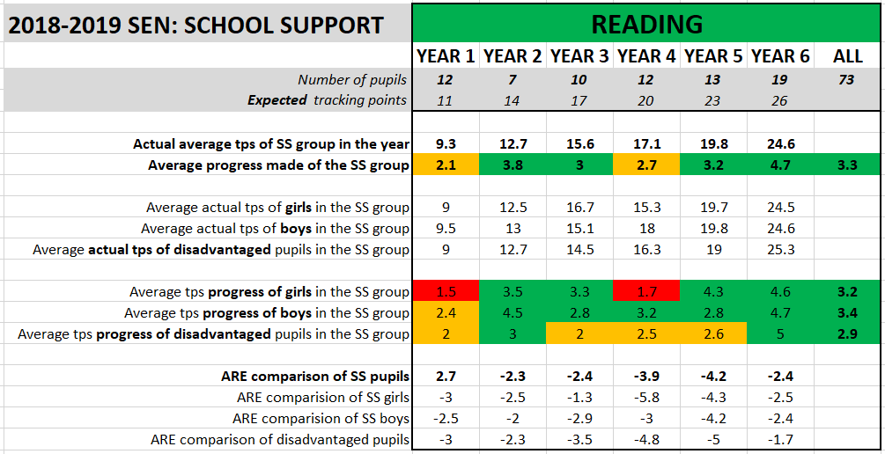

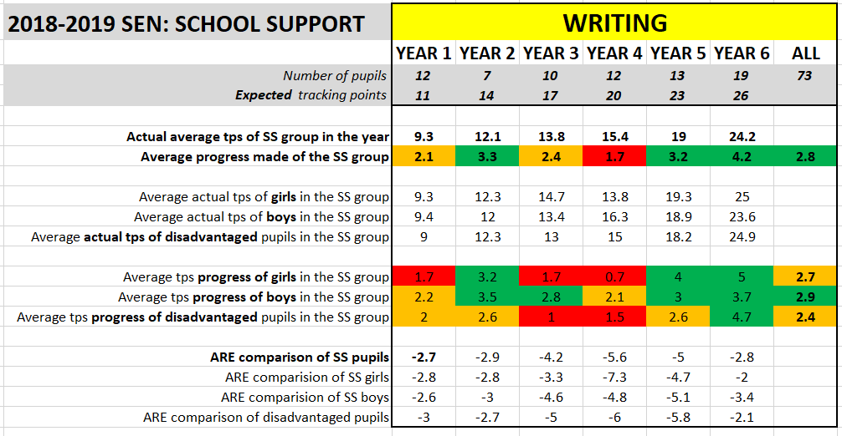

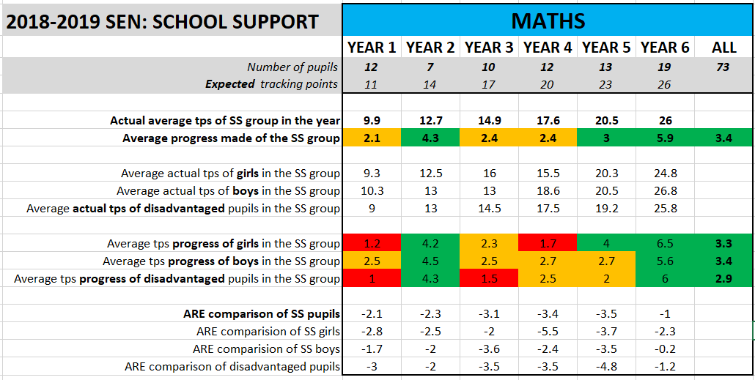

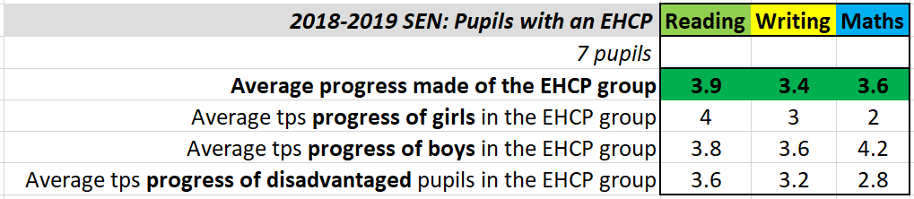

Disability Duty

Under the Disability Equality Duty schools are required to take proactive steps to ensure any disabled pupils, staff and governors, parents/carers and others using the school are treated equally. Currently, we have good facilities and access for disabled pupils within the physical environment as well as access to the curriculum. Additionally we have disabled toilet facilities.

Key aspects to develop

- Develop the SENDco’s role in terms of strategic planning and data analysis
- Target disadvantaged pupils, assess how needs are being met in all areas
- Key Stage 2 – writing interventions
- Use the new Matrix of Need and the Quality First Teaching checklists
- Induction and training of new members of staff and RQTs
- Training of all staff supporting children with EHCPs

